**Industrial Tablets & PCs With Android OS**

<https://www.alibaba.com/product-detail/Wholesale-Nfc-rfid-Lcd-Touch-Advertising_1600892205366.html?spm=a2700.galleryofferlist.p_offer.d_image.11c25462rUmeIK&s=p>

**Price:** 50 to 99 pieces US$280.00

100 to 499 pieces US$259.80

>= 500 pieces US$238.80

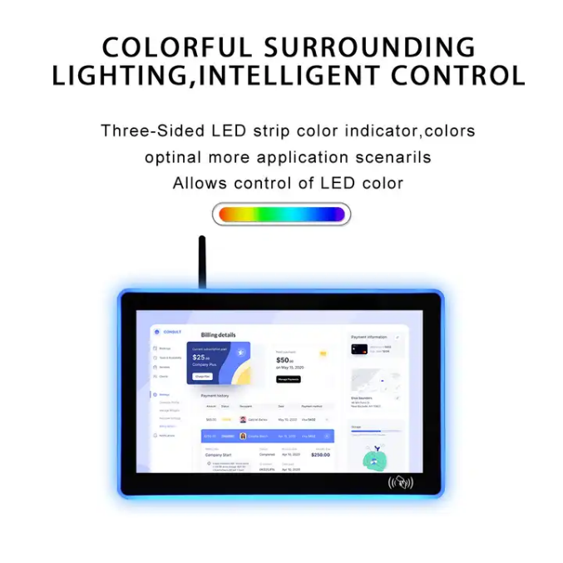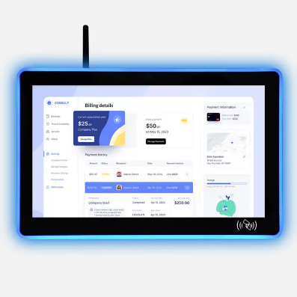

**Product Name:** GAOTek Wall Mount Android PC

**Product ID:** GAOTek-ITPA-201

**Meta Description:** This wall mount android pc has an Screen 13.3 inch, Storage 16 GGB and a system of android 11.

**Technical Specifications:**

|  |  |  |
| --- | --- | --- |
| **IP rated front panel** | IP65 |  |
| **Screen diagonal** | 13.3 in |  |
| **Display active screen size:** | 11.9 in x 6.9 in (304 mm x 177 mm) |  |
| **Aspect ratio:** | 16:10 |  |
| **Physical resolution:** | 1920 x 1080 |  |
| **Colours displayed:** | 16 M |  |
| **Brightness (cd/m2):** | 400 |  |
| **Contrast:** | 800:1 |  |
| **Storage** | 16 GGB |  |
| **USB Port** | 1 x USB 2.0 2 x USB3.0 |  |
| **HDMI** | 1 |  |
| **I/O** | RJ45+HDMI |  |  |  |
| **GPIO** | Support 3 chanel GPIO |  |  |  |
| **Wifi/Buletooth/NFC** | Support |  |  |  |
| **System** | Android 11 |  |  |  |
| **Touch Connector** | USB |  |  |  |

|  |  |  |  |  |  |  |  |  |  |  |  |  |  |  |  |  |  |  |  |  |  |  |
| --- | --- | --- | --- | --- | --- | --- | --- | --- | --- | --- | --- | --- | --- | --- | --- | --- | --- | --- | --- | --- | --- | --- |
| |  |  | | --- | --- | | **Humidity Range (RH)** | 10 % to 90 % | | **Housing material** | metal | |  |  | | **Mounting** | VESA 75 | | **Surface Hardness** | 7 H | | **Power Indicator** | Green LED | | **Power Supply** | 100 V to 240 V ACDC active switch- ing; 12V DC-Out | | **Working Power** | 12 V | | **Operating Temperature** | -4 °F to 158 °F(-20 °C to +70 °C) | | **Housing** | 11.8 in x 6.8 in x 1.3 in (284 mm x 175 mm x 35. 5 mm) | | **Gross weight** | 4.40 lb (2 kg) | |

<https://www.alibaba.com/product-detail/Industrial-Touch-Screen-Android-Panel-Pc_1601009947246.html?spm=a2700.galleryofferlist.p_offer.d_image.11c25462rUmeIK&s=p>

**Price:** 1 to 99 pieces US$266.00

100 to 499 pieces US$256.00

500 to 999 pieces US$246.00

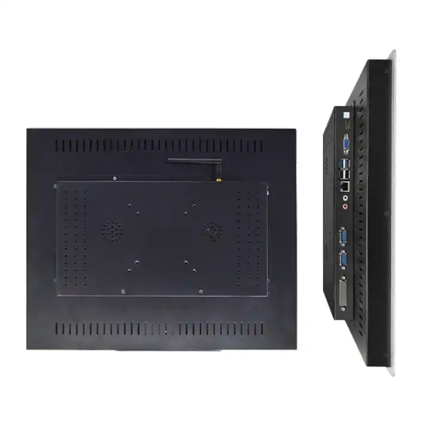>= 1000 pieces US$236.00

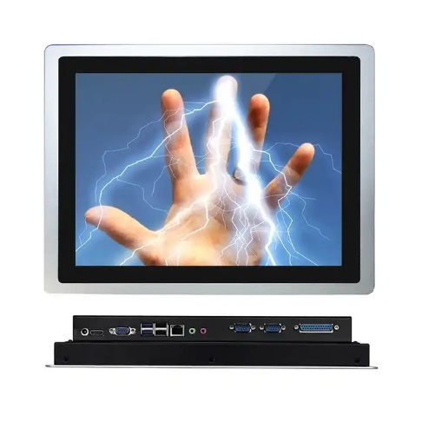

**Product Name:** GAOTek Touch Screen Computer PC

**Product ID:** GAOTek-ITPA-202

**Meta Description:** This wall mount android pc has an screen 10.4 inch ,graphics Intel HD Graphics and a cache memory 1 MB.

**Technical Specifications:**

|  |  |
| --- | --- |
| **Display Screen size** | 10.4 inch |
| **Display Brightness** | 300 cd/㎡ |
| **Display Backlight** | LED |
| **Display Screen ratio** | 0.16875 |
| **Display Response time** | 14/11 ms |
| **Resolution** | 1024 x 768 |
| **Color** | 16.2 M |
| **Backlight MTBF** | 50000 hrs |
| **Contrast ratio** | 1000:1 |
| **Viewing time** | 88/88/88/88 |

|  |  |
| --- | --- |
| **CPU** | J1800 |
| **Architecture** | BGA 1170 |
| **Main frequency** | Dual core dual thread 2.41GHz |
| **Cache** | 1 MB |
| **Graphics** | Intel HD Graphics |  |  |  |  |  |
| **RAM** | 2 G or 4 G or 8 G |
| **ROM** | 32 G SSD or 64 G SSD or 120 G SSD |
| **Support OS** | WIN7 or WIN8 or WIN10 or LINUX |
| **Cover material** | Aluminum alloy panel |
| **Power input** | DC 12V |
| **Installation method** | embedded |
| **Power consumption** | 30 W |
| **Working environment** | 32 °F to 122 ° F (0 ℃ to 50 ℃) |
| **Storage environment** | -4 °F to 140 °F (-20 ℃ to 60 ℃) |
| **Opening size** | 8.8 in x 7.09 in (226 mm x 179 mm) |
| **Over size** | 11.1 in x 8.8 in x 2.32 in (283 mm x 225 mm x 59mm) |

<https://www.alibaba.com/product-detail/Touch-Screen-All-In-1-Industrial_1601009798848.html?spm=a2700.galleryofferlist.p_offer.d_image.11c25462rUmeIK&s=p>

**Price:** 1 to 99 pieces US$265.00

100 to 499 pieces US$260.00

500 to 999 pieces US$255.00

>= 1000 pieces US$241.00

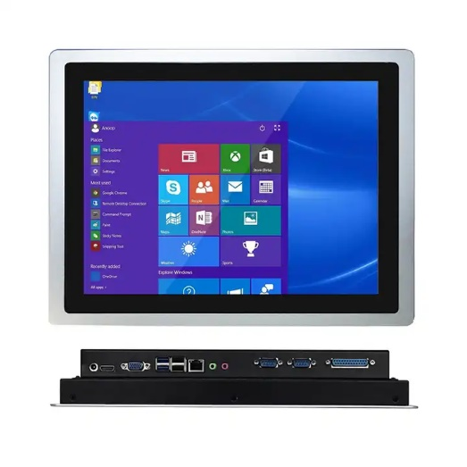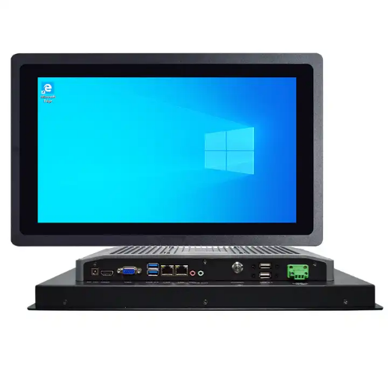

**Product Name:** GAOTek Android/Window Industrial Panel PC

**Product ID:** GAOTek-ITPA-203

**Meta Description:** This Android/Window Industrial Panel PC has an screen 17 inches , power consumption 30 W and a main frequency dual core dual thread 2.42 GHz.

**Technical Specifications:**

|  |  |
| --- | --- |
| **Resolution** | 1280 x 1024 |
| **Display Screen size** | 17 inches |
| **Display Brightness** | 250 cd/㎡ |
| **Display Backliight** | LED |
| **Display Screen ratio** | 5：4 |
| **Display Response time** | 3.6 ms or 1.4 ms |
| **Color** | 16.7 M |
| **Backlight MTBF** | 50000 hrs |
| **Contrast ratio** | 1000:1 |
| **Viewing time** | 85/85/80/80 |

|  |  |  |
| --- | --- | --- |
| **CPU** | | J1800 |
| **Architecture** | | BGA 1170 |
| **Main frequency** | | Dual core dual thread 2.41 GHz |
| **Turbo frequency** | | - |
| **Cache** | | 1 MB |
| **Graphics** | | Intel HD Graphics |
| **RAM** | 2 G or 4 G or 8 G |
| **ROM** | 32 G SSD or 64 G SSD or 120 G SSD |
| **Support OS** | WIN7 or WIN8 or WIN10 or LINUX |
| **Cover material** | Aluminum alloy panel |
| **Power input** | DC 12V |
| **Installation method** | embedded |
| **Power consumption** | 30 W |
| **Working environment** | 32 °F to 132 °F (0 ℃ to 50 ℃) |
| **Storage environment** | -4 °F to 140 ° F (-20 ℃ to 60 ℃) |
| **Over size** | 17.8 in x 14.8 in x 2.55 in (453 mm x 376 mm x65 mm) |
| **Opening size** | 15.8 in x 9.8 in (402 mm x251 mm) |

<https://www.alibaba.com/product-detail/Vandal-proof-All-in-one-PC_1600871246375.html?spm=a2700.galleryofferlist.normal_offer.d_image.11c25462rUmeIK>

**Price:** 1 to 99 pieces US$291.00

100 to 999 pieces US$271.00

1000 to 9999 pieces US$251.00

>= 10000 pieces US$231.00

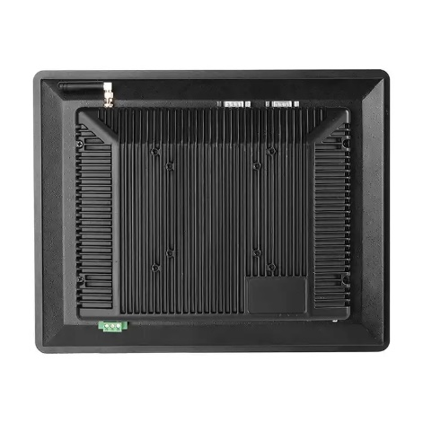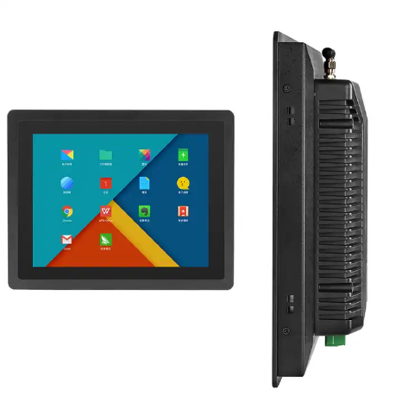

**Product Name:** GAOTek industrial Tablet PCs

**Product ID:** GAOTek-ITPA-204

**Overview:** The GAOTek Industrial Tablet PCs has 21.5inches screen is a powerful computing device designed for various industrial applications. It features a large 21.5-inch touchscreen display, complete computing capabilities, wall mounting, and a true flat design. Powered by the Android operating system, this device offers a wide range of applications and support, providing seamless functionality and user experience. The device is equipped with multiple I/O interfaces, fast network connectivity, and expandability, making it suitable for various fields such as retail, hospitality, healthcare, manufacturing, and logistics. The device's rugged build and reliable performance make it ideal for positively impacting productivity and efficiency in any industry.

**Features:**

* Embedded Computer
* Dust prevention
* Front panel IP65 waterproof
* Support interface extension
* Multiple installation modes
* Aluminum alloy housing
* Whole machine reinforcement

**Technical Specifications:**

|  |  |
| --- | --- |
| **Screen Size** | 12 Inch |
| **Screen Resolution** | 1024 x 768 |
| **CPU** | RK3288 Cortex-A17 quad-core 1.8GHz |
| **Storage** | 16 G or 32 G or 64 G EMMC |
| **Operating System** | Operating System |
| **Application** | Industrial & Automation control |
| **GPU** | Mali-T764 quad-core |
| **Memory** | 2 G |
| **Power output** | DC12V / 5A |
| **Temperature** | Working: 14°F to 140 °F (-10 °C to 60 °C)  Storage: -4 °F to 150° F(-20 °C to 70 °C) |

<https://www.alibaba.com/product-detail/1000-Nits-Embedded-Panel-Pcs-21_1600192741569.html?spm=a2700.galleryofferlist.p_offer.d_title.1ca55462MW17EI&s=p>

**Price:** 2 to 19 pieces US$645.00

20 to 49 pieces US$635.00

>= 50 pieces US$625.00

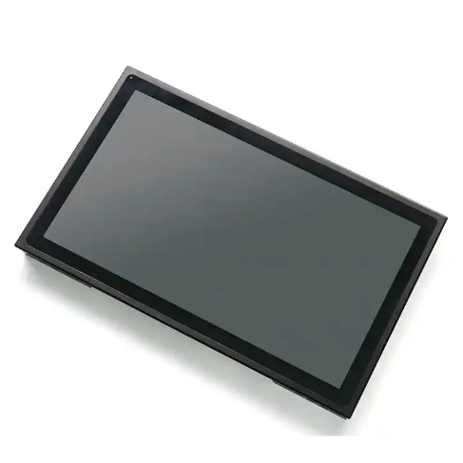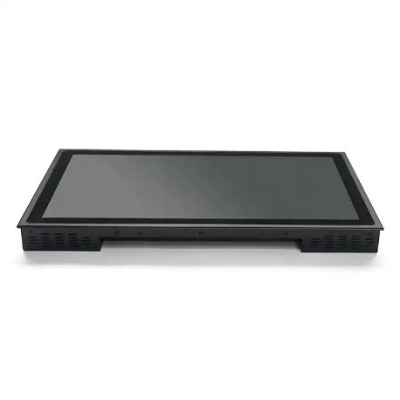

**Product Name:** GAOTek Android Panel PC

**Product ID:** GAOTek-ITPA-205

**Meta Description:** This Android Panel PC has operating system of android 7.1 , panel size 21.4 inches and a decoding resolution of 1080P.

**Technical Specifications:**

|  |  |
| --- | --- |
| **CPU** | RK3399, Dual Cortex-A72 + Quad Cortex-A53, 2.0GHz |
| **Memory** | 4GB DDR3 |
| **Storage** | 16GB EMMC |
| **Decoding Resolution** | Support 1080P |
| **Operation System (OS)** | Android 7.1 |
| **Play Modes** | Support timing, loop and spots etc. play modes |
| **Network Support** | RJ45, WIFI, 3G, 4G, TD-LTE (optional) |
| **Image Format** | JPEG/BMP/GIF/PNG |
| **Video Format** | RMVB, FLV, MPEG1/2/4, AVI, WMV, MOV, MP4, TS, etc. |
| **Audio Format** | MP3, WMA, AAC, etc. |
| **RTC Real Time Clock** | YES |
| **USB** | 2xUSB |
| **LAN** | 2xRJ45, 10M/100M adaptive ethernet |
| **HD** | 1 x HD , support 1080p |
| **Card Slot** | 1x TF card slot |
| **DC** | 1xDC |
| **Panel size** | 21.5 inches |
| **Resolution** | 1920 x 1080 |
| **Aspect ratio** | 16:9 |
| **Support Color** | 16.7 M colors |
| **Brightness** | 1000 cd/m², sunlight readable |
| **Brightness control** | Light sensor for auto dimming |
| **Response time** | 30 ms |
| **Contrast ratio** | 1000:1 |
| **View angle** | 89° or 89° or 89° or 89° (R/L/U/D) |
| **Touchscreen Type** | 10point capacitive touch |
| **Touch response time** | <2 ms |
| **Luminousness** | 90% |
| **Surface Hardness** | 7 H |
| **External Power Supply** | AC 100 V to240 V |
| **Working voltage** | DC 12 V |
| **Power consumption** | ≤45 W |
| **Material** | Aluminum alloy |
| **IP grade** | Front IP65 waterproof |
| **Relative humidity** | 5-85% (npn-condensing) |
| **Vibration resistance** | 5-19Hz/1.0mm amplitude, 19-200Hz/1.0g acceleration |
| **Impact resistance** | 10g acceleration, 11ms period |
| **Mounting way** | Embedded mounting screws (Optional) |
| Wall mounting brackets (Optional) |
| Desk stand holder (Optional) |
| **Customization (optional)** | 3 G, 4 G, Webcam, RFID reader etc. Optional |
| **Accessories** | Power adapter, power cord, embedded screws, |
| **Working temperature** | -4 °F to 158 °F (-20 °C to 70 °C) |
| **Storage temperature** | -22 °F to 176 °F (-30 °C to 80 °C) |
| **Product dimension** | 21.2 in x 12.9 in x 1.8 in (537 mm x 328.5 mm x 48 mm) |
| **Packing size** | 28.7 in x 17.7 in x 7.4 in (730 mm x 450 mm x190 mm) |
| **Net weight** | 15.4 lb (7 kg) |
| **Gross weight** | 19.4 lb (9 kg) |

<https://www.alibaba.com/product-detail/4G-64GB-IP67-RK3399-6000mAh-10_1600881245934.html?spm=a2700.galleryofferlist.p_offer.d_title.1ca55462MW17EI&s=p>

**Price:** 2 - 49 pieces US$334.00

50 - 299 pieces US$321.00

300 - 9999 pieces US$307.00

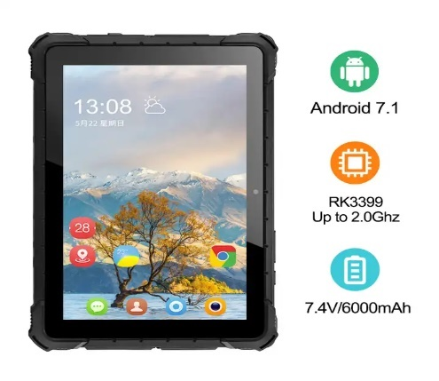>= 10000 pieces US$294.00

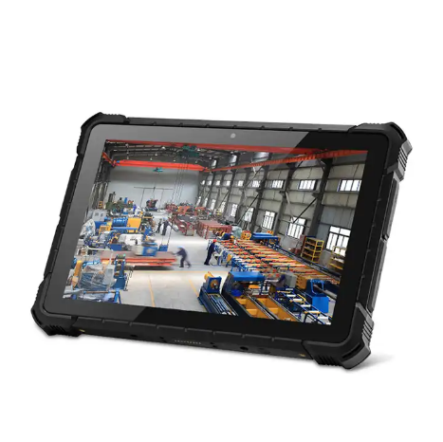

**Product Name:** GAOTek Android Rugged Industrial Tablet

**Product ID:** GAOTek-ITPA-206

**Meta Description:** This Android Rugged Industrial Tablet has battery of 6000 mAh, CPU of RK33390 6-core and a screen size 10.1 inch.

**Technical Specifications:**

|  |  |
| --- | --- |
| **Screen size** | 10.1 inch |
| **Screen resolution** | 1920 x 1200 IPS |
| **TP Touch screen** | G+G Capacitive touch screen |
| **Battery** | 7.4 V or 6000 mAh |
| **Camera** | front 2 megapixels/rear 5 megapixels |
| **Microphone recording** | Stereo built-in 8 Ω/1W x 2 Waterproof loudspeaker |

|  |  |
| --- | --- |
| **CPU** | RK3399 6-core,A72 The highest frequency 2.0 GHz、A53 The highest frequency 1.5 GHz |
| **GPU** | Mali-T860 |
| **RAM/ROM** | 4 GB / 64 GB |
| **Fingerprint** | Support biometric fingerprint identification |
| **2D scanner** | LA3296 |

|  |  |
| --- | --- |
| **WIFI** | WIFI 802.11 ac/b/g/n |
| **Bluetooth** | BT 4.0 AP6255 |
| **Ethernet RJ45** | Support 1000 M PCIE RTL8111F |
| **GPS** | built-in GPS+ BeiDou（LINKLAB UB-118） |

|  |  |
| --- | --- |
| **TF Card** | Can Support 64GB High-speed TF card |
| **Earphone Interface** | ∮3.5mm standard headphone jack x 1 |
| **Micro USB2.0** | Support USB OTG function x 1 |
| **Power adapter** | 12 V or 3 A |
| **Size** | 10.74 in x 7.4 in x 1.02 in (273 mm x 189 mm x26.5 mm) |
| **Weight** | 2. 4 lb (1.12 kg) |

<https://www.alibaba.com/product-detail/Android-Industrial-Touch-Screen-Panel-Pc_1600694642018.html?spm=a2700.galleryofferlist.p_offer.d_image.1ca55462MW17EI&s=p>

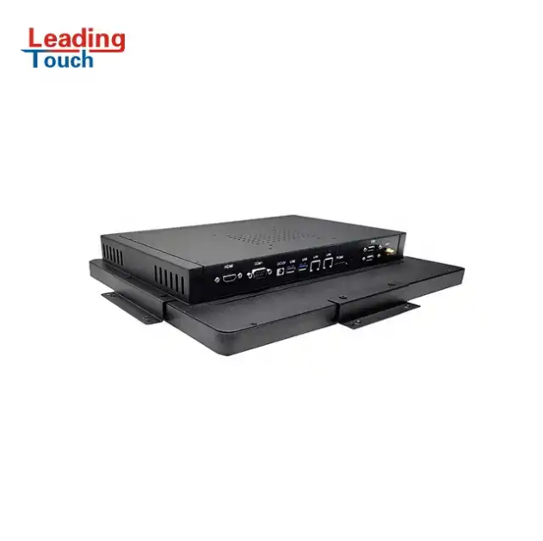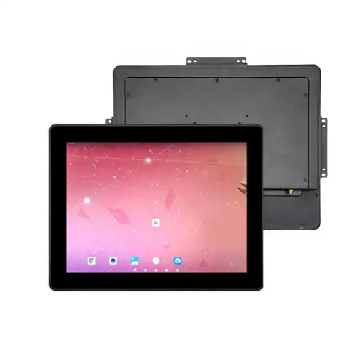**Price:** >= 100 pieces US$300.00

**Product Name:** GAOTek Touch Screen Panel PC

**Product ID:** GAOTek-ITPA-207

**Meta Description:** This Touch Screen panel PC has operating system Android 7.1, CPU of quad-core and a display size of 15 inch.

**Technical Specifications:**

|  |  |
| --- | --- |
| **Display Size** | 15 inch 4:3 Active Matrix TFT LCD |
| **Useful Screen Area** | 12 in x 9 in (305 mm x 229 mm) |
| **Optimal Resolution** | 1024 x 768 |
| **Color Depth** | 8bit,16.7 Million colors |
| **Brightness** | 300 cd/m2 |
| **Contrast Ratio** | 700:1 (Typical) |
| **Viewing Angle (CR>10)** | R/L 80° /80° U/D 80°/80° |

|  |  |
| --- | --- |
| **Android OS** | 7.1 |
| **CPU** | Quad-core ARM Contex-A17 up to 1.8G |
| **GPU** | Mail-T764 GPU |
| **RAM and ROM Flash** | RAM:2 G DDR3(4 G Options) ROM Flash：8 GB (16G/32G Options) |
| **SD and SIM Card Socket** | SD Card Socket:1,(Max 32G) SIM Card Socket:1 |
| **USB and COM Port** | 4 x USB Port, 2 x RS232 COM Port (485Options) |
| **OTG Port** | 1 x OTG |
| **Video Input** | 1 x HDMI |
| **Ethernet Port** | 1 x LAN RJ45(Gigabit) |
| **Wireless** | Wi-Fi 802.11 a/b/g/n/ac |
| **Bluetooth** | Bluetooth 4.0 |
| **Audio and Microphone** | 1 mm x 3.5 mm line out 1 x microphone out |
| **Speaker** | 2 W x 12 W internal speakers |
| **4G Module** | Options |
| **Touch Technology** | Project Capacitive touch Technology |
| **Mounting Options** | VESA 75 and 100 and External Bracket |
| **Power Supply** | DC12 V or 5 A Power Ripple <50 WV External Adapter: 100 VAC to 240VAC, 50 Hz to 60 Hz, POE optional |
| **Humidity Range** | Operating: 20% to 80%  Storage: 10% to 90%( (no condensing) |
| **Temperature Range** | Operating: 32 °F to 122 °F (0 °C to 50 °C)  Storage: -4 °F to 140 ° F(-20 °C to 60 °C) |
| **Dimension** | 14.4 in x 11.2 in x 2.03 in (363mm x 289.9mm x 51.8mm) |

<https://www.alibaba.com/product-detail/8-Inch-Industrial-Android-7-1_1600450267640.html?spm=a2700.galleryofferlist.p_offer.d_image.1ca55462MW17EI&s=p>

**Price:** 1 to 19 pieces US$449.00

20 to 49 pieces US$439.00

50 to 99 pieces US$429.00

>= 100 pieces US$419.00

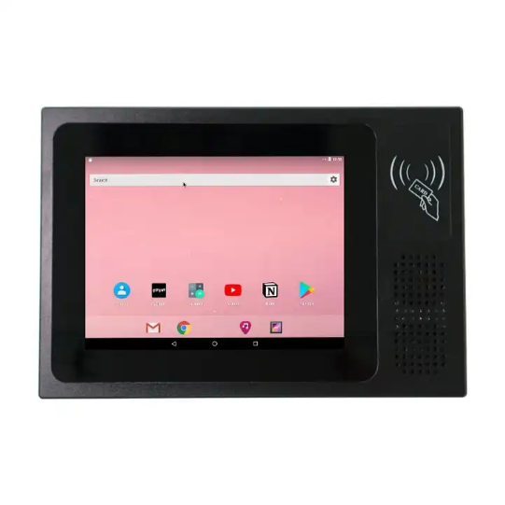

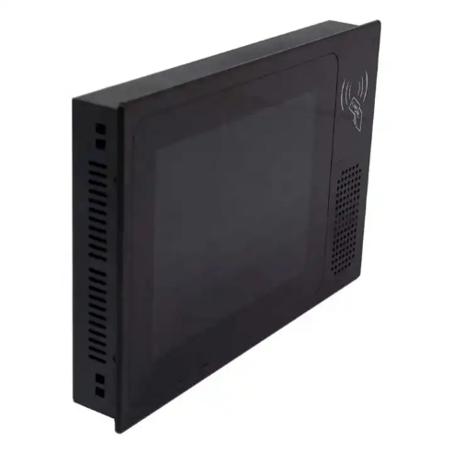

**Product Name:** GAOTek Touch Screen Tablet with NFC

**Product ID:** GAOTek-ITPA-208

**Meta Description:** This Touch Screen Tablet with NFC has Panel size 8 inch, working voltage 12 V and operating system android 7.1.

**Features:**

* Support all sizes of USB2.0 connector
* Support Docking charger docking extension
* Support NXP NFC (13.56 M, distance 5cm or above)
* Support GPS navigation
* Support 2D barcode scanner optional
* Support finger identification optional
* Rugged IP65 protection level
* Support 10500 mAh pluggable battery
* Support serial port, internet port and customized port

**Technical Specifications:**

|  |  |
| --- | --- |
| **CPU** | RK3399, Dual Cortex-A72 + Quad Cortex-A53, 2.0 GHz |
| **Memory** | 4 GB DDR3 |
| **Storage** | 16 GB EMMC |
| **GPU** | ARM Mali-T860MP4 (600 MHz) |
| **Decoding Resolution** | Support 1080P |
| **Operation System** | Android 7.1 |
| **Play Modes** | Support timing, loop and spots etc. play modes |
| **Network Support** | RJ45, WIFI, 3G, 4G, TD-LTE (optional) |
| **Image Format** | JPEG/BMP/GIF/PNG |
| **Video Format** | RMVB, FLV, MPEG1 or 2 or 4, AVI, WMV, MOV, MP4, TS, etc. |
| **Audio Format** | MP3, WMA, AAC, etc. |
| **RTC Real Time Clock** | YES |
| **USB** | 2xUSB |
| **LAN** | 2 x RJ45, 10M/100M adaptive ethernet |
| **Card Slot** | 1 x TF card slot |
| **DC** | 1 x DC |
| **Phoenix terminal** | 1xPhoenix terminal |
| **Panel size** | 8 inch |
| **Resolution** | 1024 x 768 |
| **Aspect ratio** | 4:3 |
| **Support Color** | 16.7M colors |
| **Brightness** | 300 cd/m² |
| **Response time** | 5 ms |
| **Contrast ratio** | 800:1 |
| **View angle** | 80°/80°/80°/80° (R/L/U/D) |
| **Touchscreen Type** | 10point capacitive touch |
| **Touch response time** | <2 ms |
| **Luminousness** | 90% |
| **Surface Hardness** | 7 H |
| **Working Life** | >50 million times |
| **External Power Supply** | AC 100 V to 240 V |
| **Working voltage** | DC 12 V |
| **Power consumption** | ≤15 W |
| **Appearance** | Flat panel |
| **Material** | Aluminum alloy |
| **Color** | Black, Silver |
| **VESA mounting** | 100x100mm |
| **IP grade** | Front IP65 waterproof |
| **Relative humidity** | 5-85% （non-condensing） |
| **Vibration resistance** | 5-19 Hz/1.0 mm amplitude, 19-200Hz/1.0g acceleration |
| **Impact resistance** | 11 ms period |
| **Accessories** | Power adapter, power cord, embedded screws |
| **Mounting way** | wall mounting bracket (optional) |
|  | desk stand holder (optional) |
| **Packing size** | 18.8 in x 14.4 in x 5.1 in (480 mm x 380 mm x 130 mm) |
| **Product dimension** | 10.6 in x 7.2 in x 1.5 in (260 mm x 182 mm x 38 mm) |
| **Working temperature** | 14 °F to 140 °F (-10 °C to 60 °C) |
| **Storage temperature** | -4 °F to 140 °F (-20°C to 60°C) |
| **Net weight** | 5.1 lb (2.35 kg) |
| **Gross weight** | 6.2 lb (2.85 kg) |

<https://www.alibaba.com/product-detail/10-1-Rugged-Tablet-android-9_1600295368558.html?spm=a2700.galleryofferlist.normal_offer.d_title.1ca55462MW17EI>

**Price:** 1 to 499 pieces US$195.75

500 to 999 pieces US$181.25

1000 to 9999 pieces US$174.00

>= 10000 pieces US$166.80

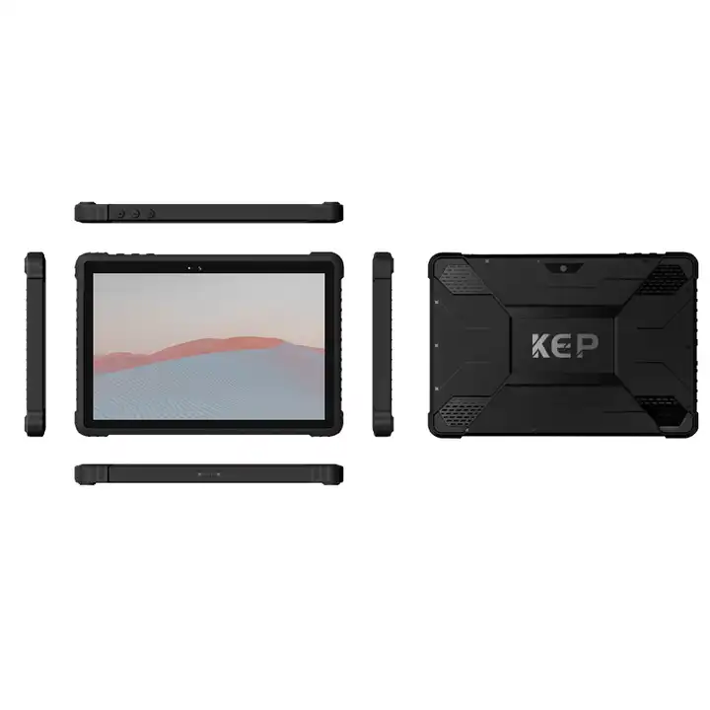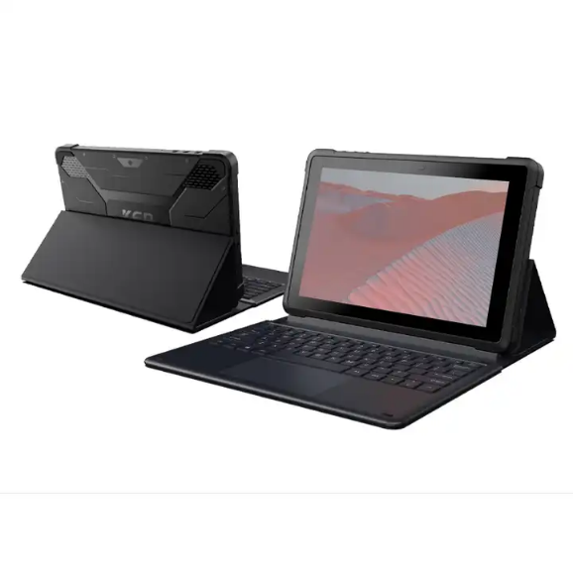

**Product Name:** GAOTek Tablet Android 9 OS

**Product ID:** GAOTek-ITPA-209

**Meta Description:** This Tablet Android 9 OS has 3 GB RAM 32 GB ROM , 4GB CPU NFC RFID and barcode scanner reader customized.

**Features:**

* Support all sizes of USB2.0 connector
* Support Docking charger docking extension
* Support NXP NFC (13.56 M, distance 5cm or above)
* Support GPS navigation
* Support 2D barcode scanner optional
* Support finger identification optional
* Rugged IP65 protection level
* Support 10500 mAh pluggable battery
* Support serial port, internet port and customized port

**Technical Specifications:**

|  |  |  |
| --- | --- | --- |
| **System** | Android 11 | |
| **Waterproof level** | IP65 |
| **LCD** | 10.1" 1200*1920 FHD IPS |
| **CPU** | MTK8788 |
|  | |
| **GPU** | ARM G72 MP3 800GHz |  | |
| **RAM** | 2GB or 3GB or 4GB |  | |
| **ROM** | 16GB or 32GB or 64GB or 128GB |  | |
| **Front Camera** | 2 MP or 5 MP （Optional） |  | |
| **Rear Camera** | 5 MP or 8 MP （Optional） |  | |
| **4G** | CDMA2000:BCO (optional)  TDSCDMA:BAND 34/39  FDD: B1/2/3/5/7/8/20 or B2/4/5/7/12/17 or 2/4/5/7/17/28A optional  TDD:BAND 38/39/40/41 | | |
| **I/O Ports** | 1XMicro HD MI/1X3.5mm earphone jack/1XUSB 3.0/1XTF/1XType-C | | |
|
|
| **Wi-Fi** | WIFI 802.11 ac/a/b/g/n 2.4G+5G; BT 5.0 | | |
| **Blue tooth** | BT 5.0 | | |
| **NFC** | NXP PN553 | | |
| **Battery** | 3.7 V or 8000 mAh | | |
| **Adaptor** | Type-C USB 2.0 ,9V/2 OR 5V/3A PE+Fast charge | | |
| **size** | 7.6 in x 10.6 in x 0.7 in (185.7 mm x 269.7 mm x 20 mm) | | |
| **Weight** | 1.98 lb (0.9 kg) | | |

<https://nstouch.en.made-in-china.com/product/VnlUqFwPMOhb/China-17-Inch-Ultra-Thin-Display-2g-Emmc-8g-Rk3288-Waterproof-Touch-Screen-Android-OS-Embedded-Industrial-Tablet-PC.html>

**Price:** US$360.00 to 380.00 / Piece

**Product Name:** GAOTek Embedded Industrial Tablet PC

**Product ID:** GAOTek-ITPA-2010

**Meta Description:** This Embedded Industrial Tablet PC has operating system 7.1.2 , Screen size 17 inch and a 2g Emmc 8g RK3288.

**Features:**

* Metal material
* Stable and efficient
* Fashionable and beautiful
* HD display
* Multi touch screen
* Explosion-proof screen
* Waterproof and dustproof
* High and low temperature resistance
* Interface support customization

**Technical Specifications:**

|  |  |
| --- | --- |
| **Display screen** | TFT-LED |
| **Screen Size** | 17 inches |
| **Screen ratio** | 5:4 |
| **Effective display area** | (337.92 mm ×270.336 mm) |
| **Resolution** | 1280 x 1024 |
| **Brightness** | 250 cd/m² |
| **Contrast Ratio** | 1000:1 |
| **Viewing Angle** | 89/89/89/89 (TyP.) (CR≥10) |
| **Response time** | 20 (Typ.) (Tr/Td) ms |
| **Waterproofness** | Front waterproofing |
| **Glass** | Toughened glass, optional AG cover plate |
| **Transmittance of light** | >90% |
| **Frame** | Aluminum profile surface treatment, with anti-interference ability |
| **Touch type** | capacitive touch screen (G+G) |
| **Max. Support Points** | Ten Spot |
| **Touch mode** | Finger touch (stylus optional) |
| **Surface hardness** | ≥6 H |
| **Response time** | <3 ms |
| **passing rate** | ≥85% |
| **Service life** | >50 million times |
| **Communication mode** | Full speed USB |
| **CPU** | standard configuration: RK3288,Cortex-A17,quad-core,1.8 GHz |
| **GPU** | quad-core,Mail-T764 |
| **operating system** | Android 7.1.2 |
| **memory** | standard configuration: 2 G, optional:4 G |
| **rom** | standard configuration: EMMC 8G, optional: 16G/32G/64G |
| **network interface** | RJ45 10/100M network adaptation; Support Wi-Fi/Bluetooth 4.0;Wireless Peripheral Expansion |
| **USB interface** | USB HOST x 2 |
| **HDMI output** | X 1, support 1080 P 60 Hz |
| **audio output** | Dual-channel stereo audio output |
| **TF card** | support TF card |
| **4G** | Built-in Mini PCI-E interface, support 4G full network connection |
| **Working Humidity** | 20% to 80 % |
| **Working temperature** | -4 °F to 140 °F (-20 °C to 60 °C) |
| **Specification of the machine** | 16.2 in x 13.2 in (413 mm ×342 mm) |
| **Equipment thickness** | 2.5 in (64.2 mm) (thickness) |
| **Hole size** | 15.3 in x 12.6 in (390.5 mm × 322 mm) |